ASSIGNMENT 3

NAME – KONAKALLA AKHILA ROLL NUMBER – DXC-262-AB-1225

BATCH – DXC-262-ANALYTICS-B12-AZURE COMPANY – DXC TECHNOLOGY EMPLOYEE DOMAIN –AZURE ANALYTICS

TRAINING UNDER – MANIPAL PRO LEARN TRAINER NAME – MR. AJAY KUMAR DATE OF SUBMISSION – 1ST JUNE 2022 NO.OF CASES: 11

CASE 21: From the following table, write a SQL query to find those employees whose experience is more than 27 years.Return complete information about the employees

QUERY : **select *from GLOBETECHTB231 where months_BETWEEN(SYSDATE,HIRE_DATE)>27*12;**

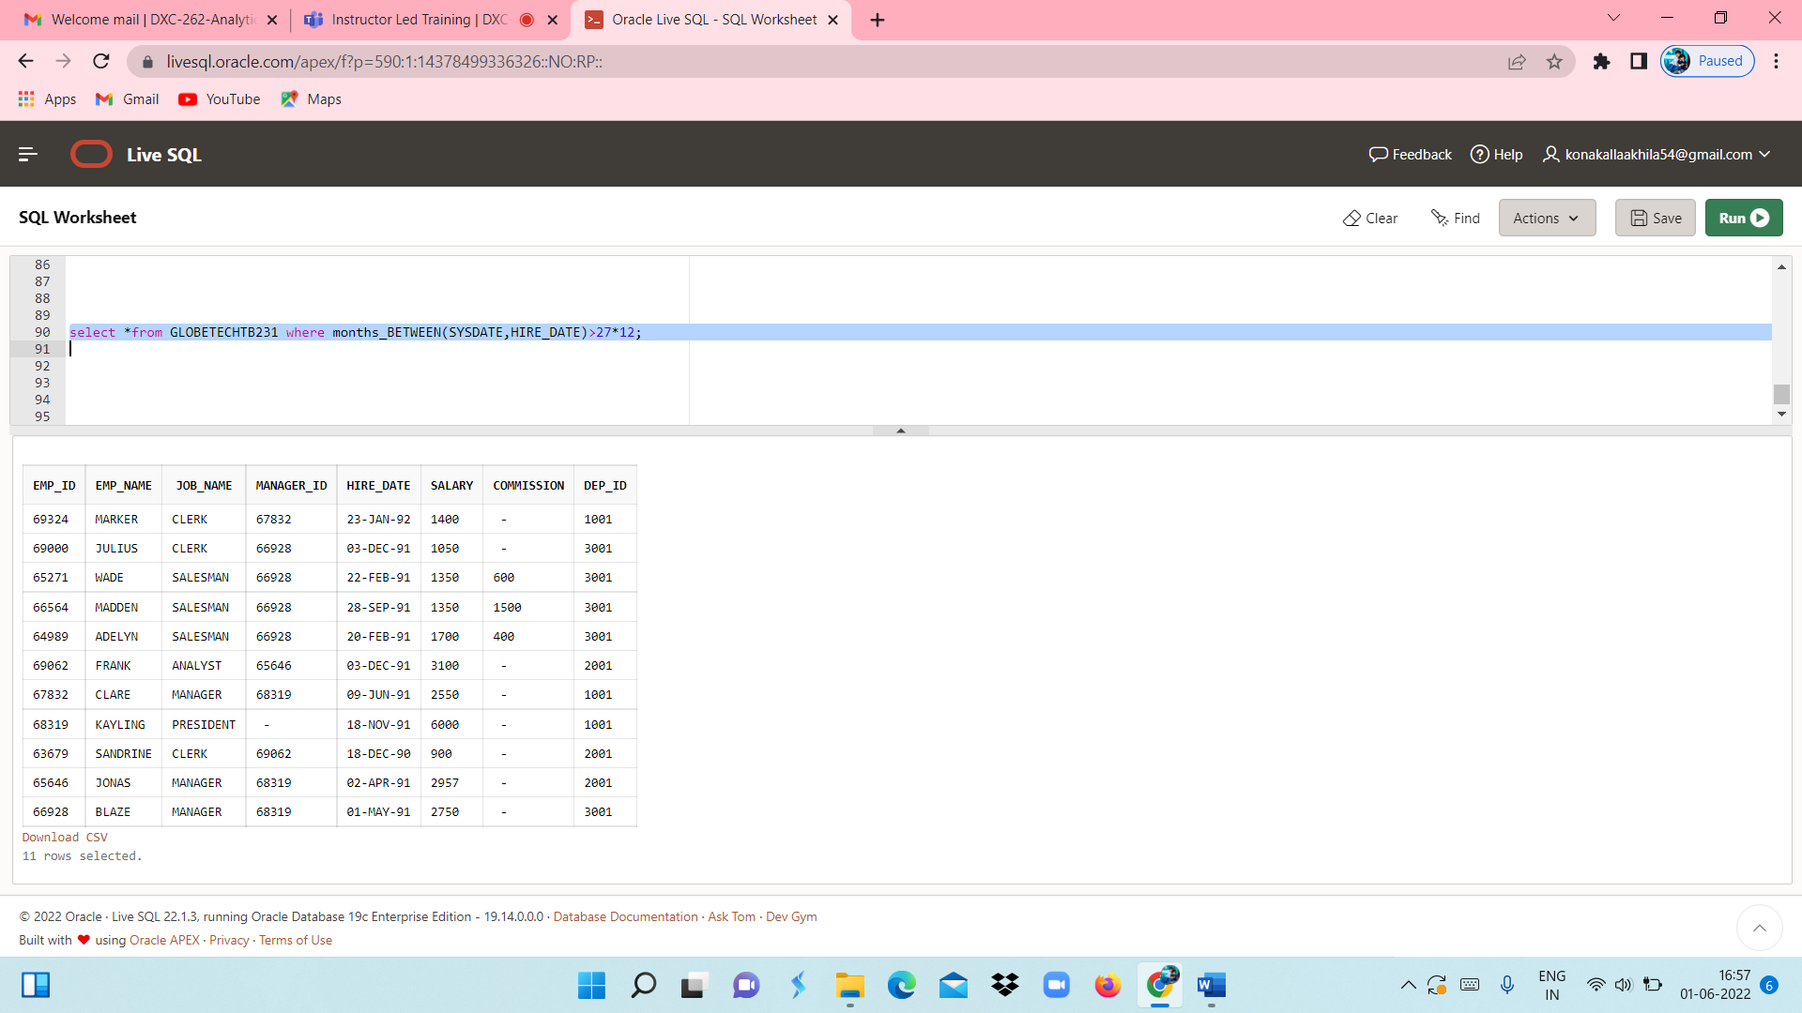

CASE 22: From the following table, write a SQL query to find those employees whose salaries are less than 3500.  
Return complete information about the employees

QUERY: **select *from GLOBETECHTB231 where SALARY<3500;**

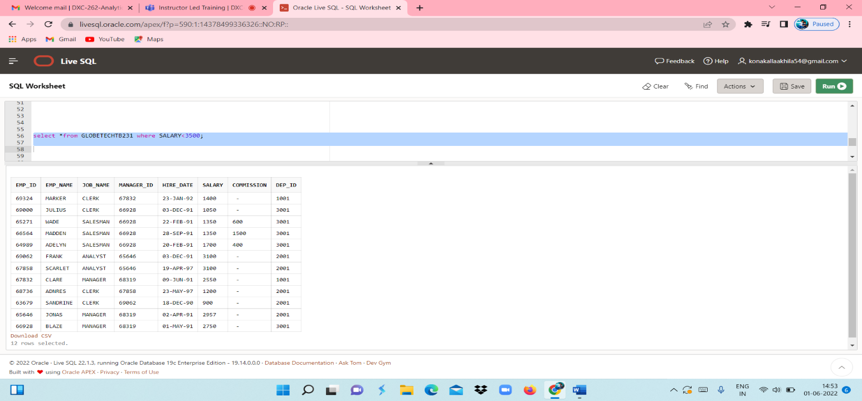

CASE 23: From the following table, write a SQL query to find the employee whose designation is ‘ANALYST’.  
Return employee name, job name and salary

QUERY: **select EMP_NAME,JOB_NAME,SALARY from GLOBETECHTB231 where JOB_NAME='ANALYST';**

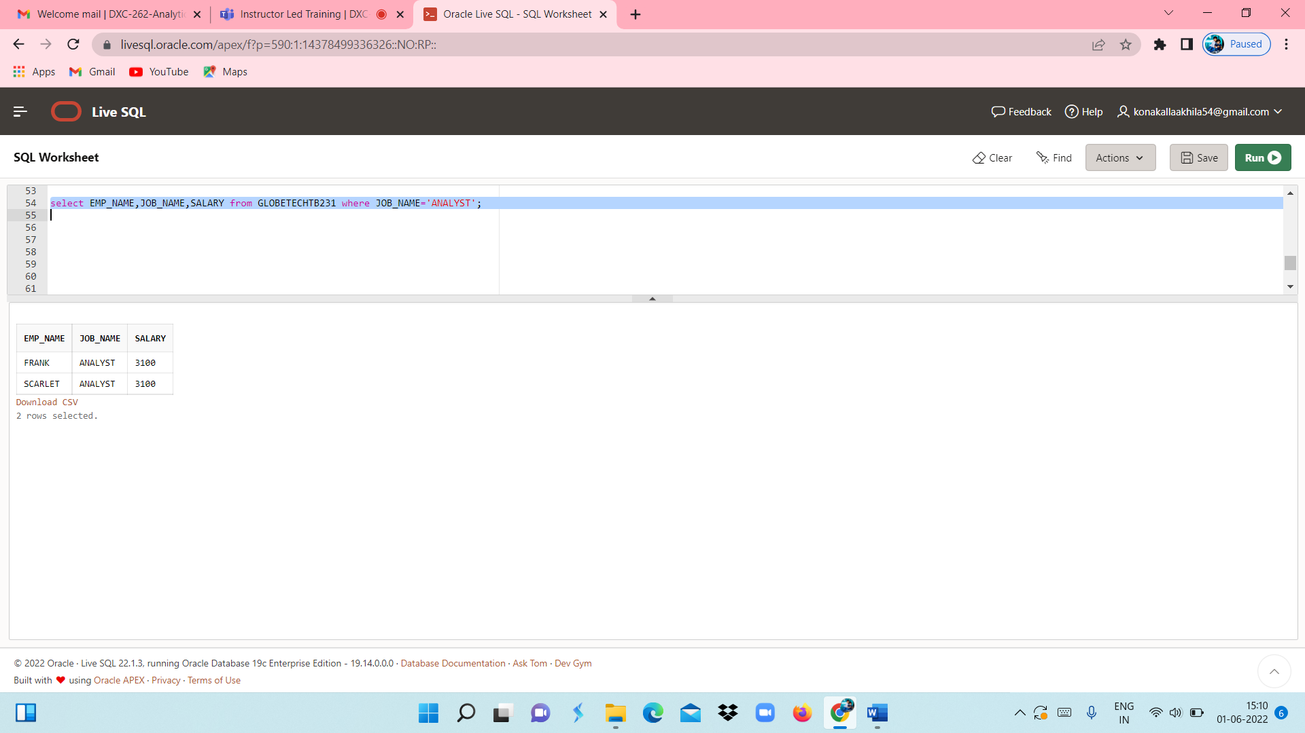

CASE 24: From the following table, write a SQL query to find those employees who have joined in the year 1991.  
Return complete information about the employees

QUERY: **select *from GLOBETECHTB231 where to_char(HIRE_DATE,'YYYY')='1991'** From the following table, write a SQL query to find those employees who joined before 1st April 1991.  
Return employee ID, employee name, hire date and salary**;**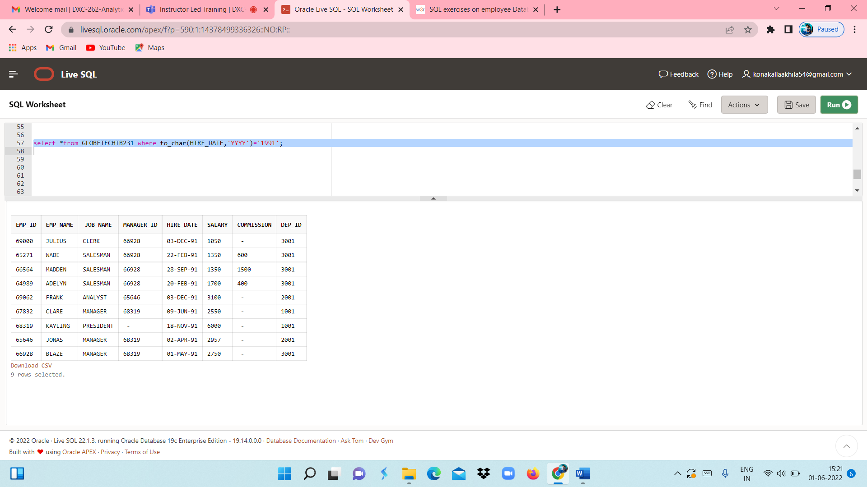

CASE 25: From the following table, write a SQL query to find those employees who joined before 1st April 1991.  
Return employee ID, employee name, hire date and salary

QUERY1 : **select EMP_ID,EMP_NAME,HIRE_DATE,SALARY from GLOBETECHTB231 where to_char(HIRE_DATE,'YYYY-MM-DD') < '1991-04-01';**

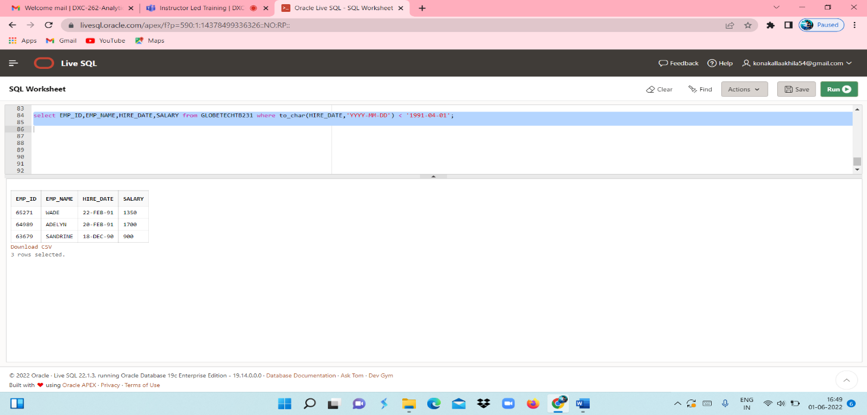

CASE 26: From the following table, write a SQL query to find those employees who are not working under a manager.  
Return employee name, job name.

QUERY**: select EMP_NAME,JOB_NAME from GLOBETECHTB231 where JOB_NAME!='manager';**

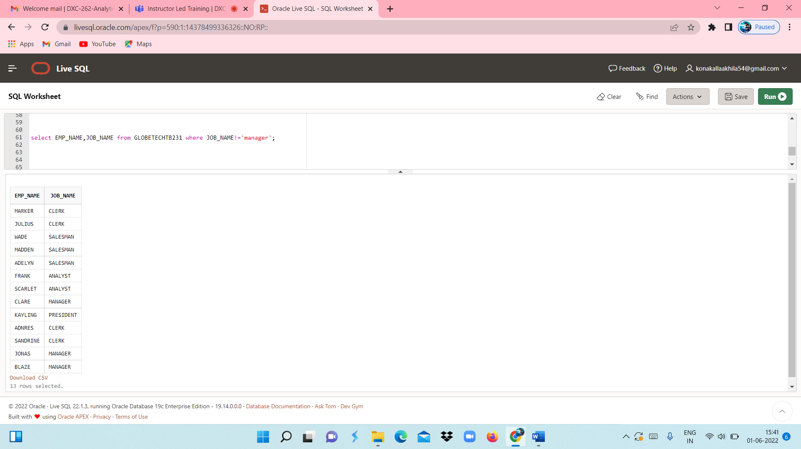

CASE 27: From the following table, write a SQL query to find those employees who joined on 1st May 91.  
Return complete information about the employees.

QUERY: **select *from GLOBETECHTB231 where to_char(HIRE_DATE,'YYYY-MM-DD')='1991-05-01';**

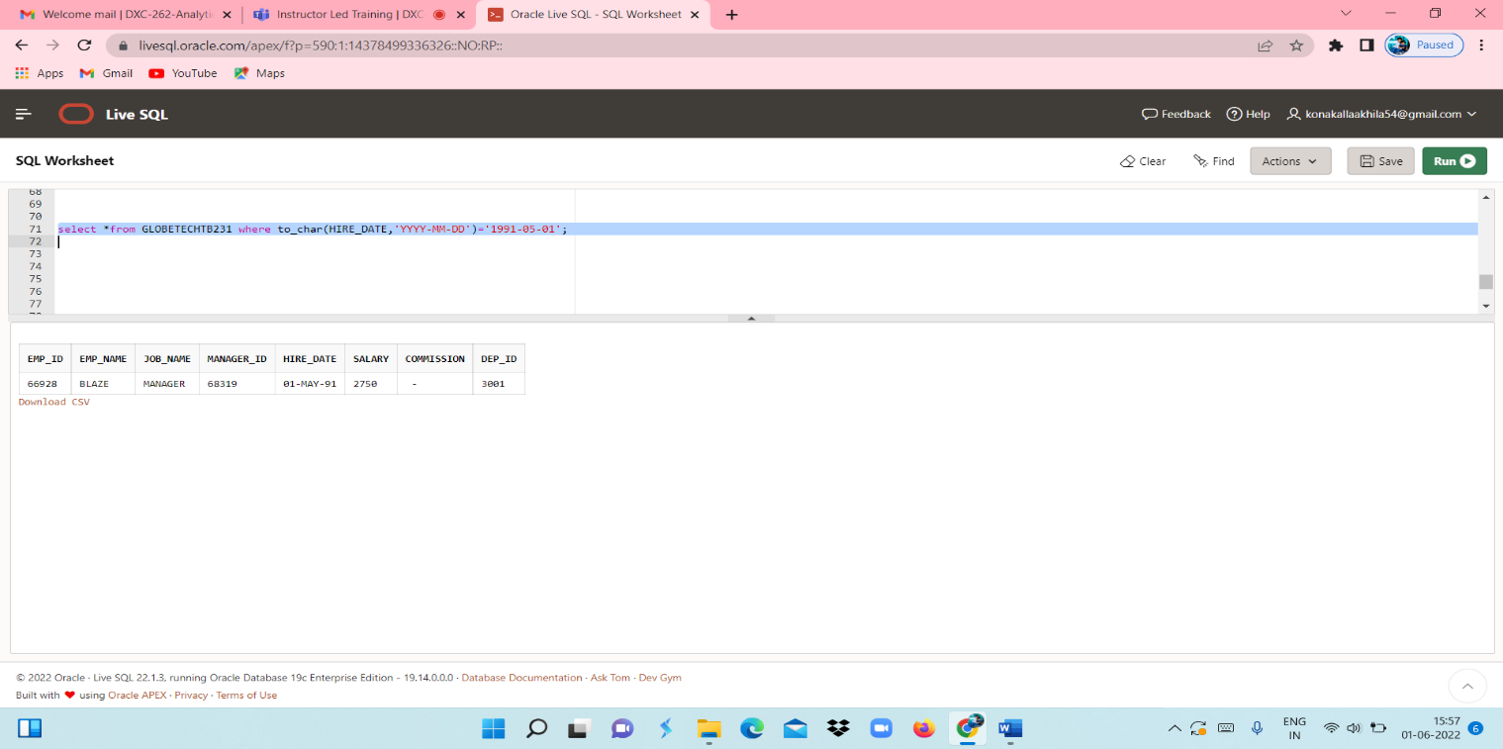

CASE 28: From the following table, write a SQL query to find those employees working under the manger whose ID is 68319.

QUERY: **select *from GLOBETECHTB231 where MANAGER_ID='68319';**

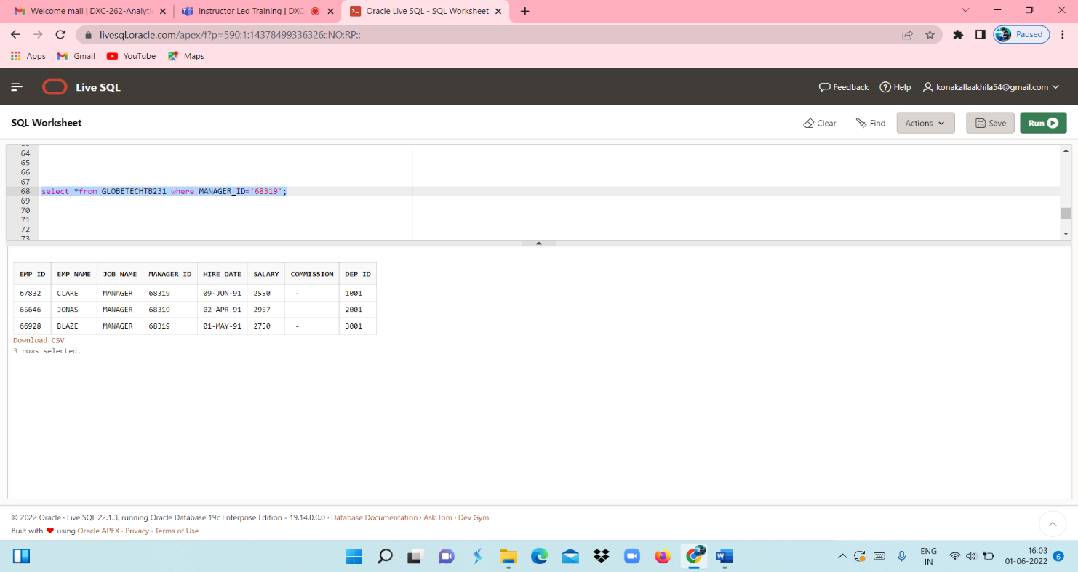

CASE 29: From the following table, write a SQL query to find those employees who earn more than 100 as daily salary.  
Return employee ID, employee name, salary, and age.

QUERY:

**select EMP_ID,EMP_NAME,SALARY from GLOBETECHTB231 where (SALARY/30)>100;**

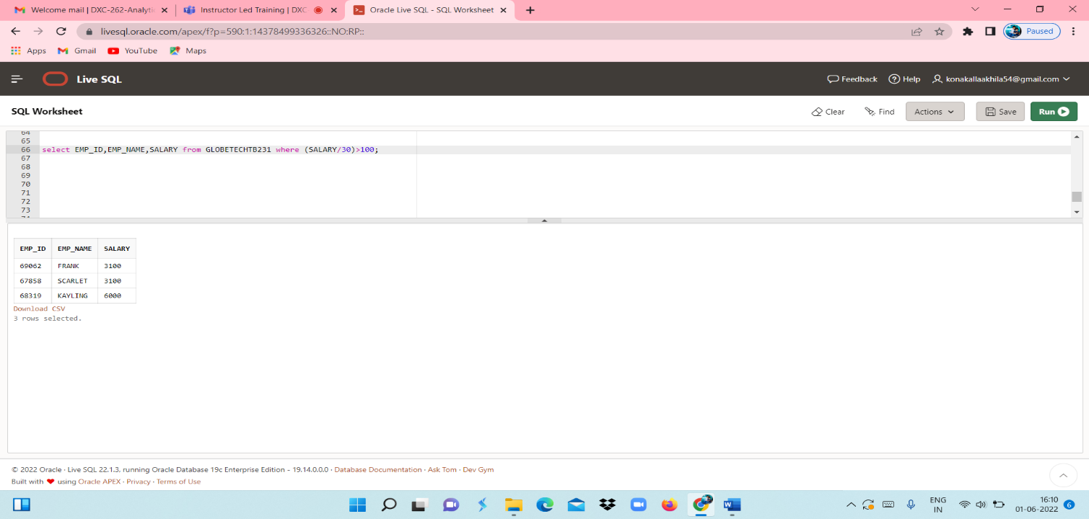

CASE 30: From the following table, write a SQL query to find those employees who retired after 31-Dec-99,  
completion of 8 years of service period. Return employee name.

QUERY: **select EMP_NAME from GLOBETECHTB231 where HIRE_DATE>TO_DATE('1992-01-01','YYYY-MM-DD');**

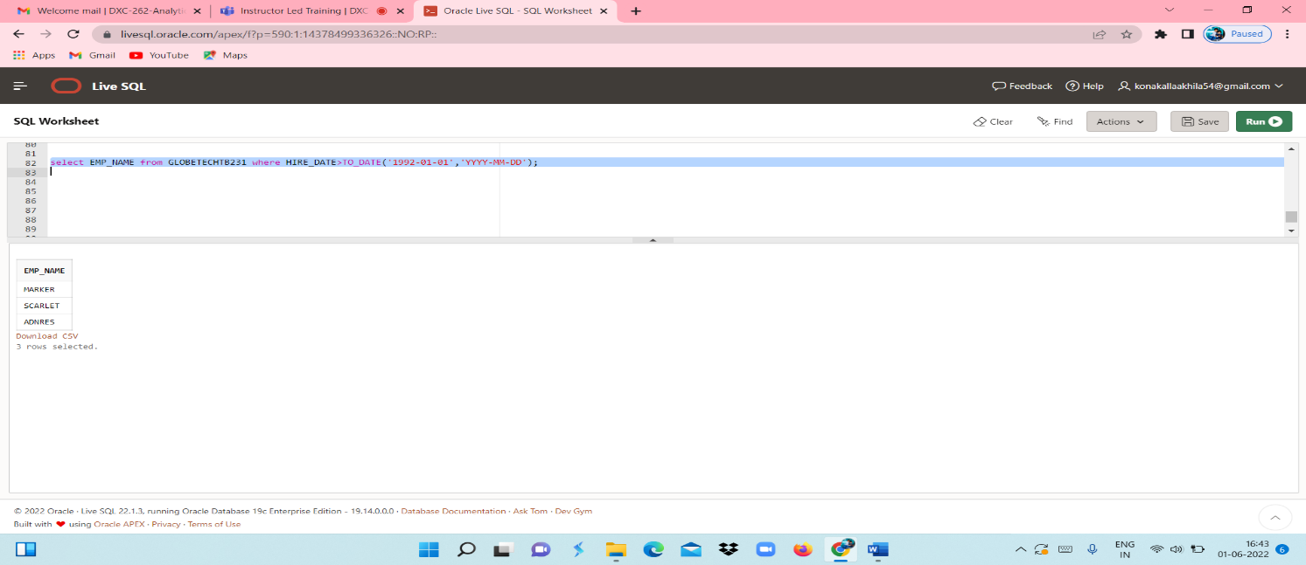

CASE 31: From the following table, write a SQL query to find those employees whose salary is an odd value.  
Return complete information about the employees.

QUERY: **select *from GLOBETECHTB231 where mod(SALARY,2) != 0;**

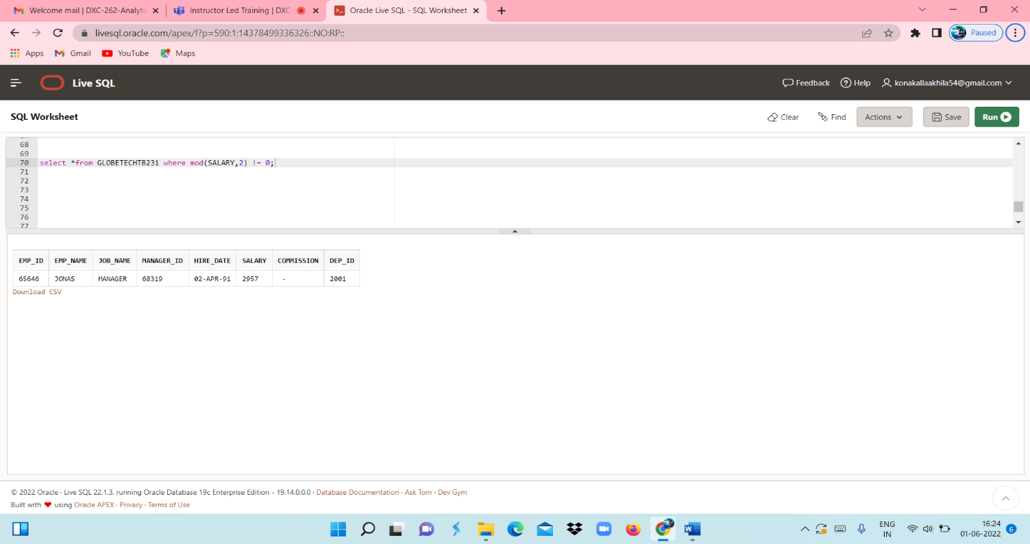

CASE 32: From the following table, write a SQL query to find those employees whose salary contains only three digits.  
Return complete information about the employees.

QUERY**: select *from GLOBETECHTB231 where length(trim(to_char(SALARY,'9999')))= 3;**

